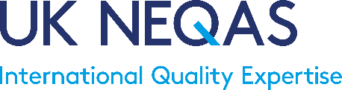

20th March 2020

Dear Valued Participants and Distributors,   
  
We are aware that the recent coronavirus (COVID-19) outbreak is making it difficult for laboratories across the world to deliver core services. In response to this situation, UK NEQAS centres may be able to extend exercise deadlines for all new and current external quality assessment (EQA)/Proficiency Testing (PT) exercises issued. If you are unable to provide a result at all for any exercises, or if you want to request an extension please contact the individual centre by your usual route and we will do everything we can to facilitate such requests.

All UK NEQAS centres have service continuity plans in place, however, changes to exercise distribution schedules may become necessary over the next few months if the spread of COVID-19 affects EQA/PT material availability or impacts on the transport infrastructure used to distribute exercises. If this occurs, then you will be notified of any delays directly by the relevant UK NEQAS centre. Additionally, details of all UK NEQAS service changes will also be published on the central UK NEQAS website ([www.ukneqas.org.uk](http://www.ukneqas.org.uk)) and will be available on our Twitter feed (@UKNEQAS).

As you are aware the COVID-19 situation is rapidly changing. In this unprecedented situation, UK NEQAS is taking these steps to support centres under pressure due to increased workloads and changes in local staff availability during the current pandemic but still ensure that the necessary EQA/PT framework is in place to support laboratories.

We thank you for your continued support in this difficult time and we hope that the current situation improves soon.

Yours sincerely

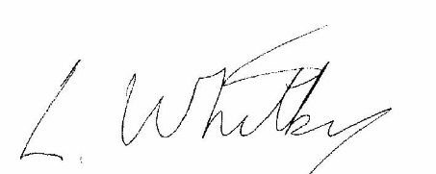 

Mr Liam Whitby Deborah Pritchard

**President of UK NEQAS UK NEQAS for H&I Deputy Director**